Emerson Zamensky | Policy Brief

**Resource and Food Preservation: Utilization of Hydroponic Systems in Place of Conventional Agriculture** 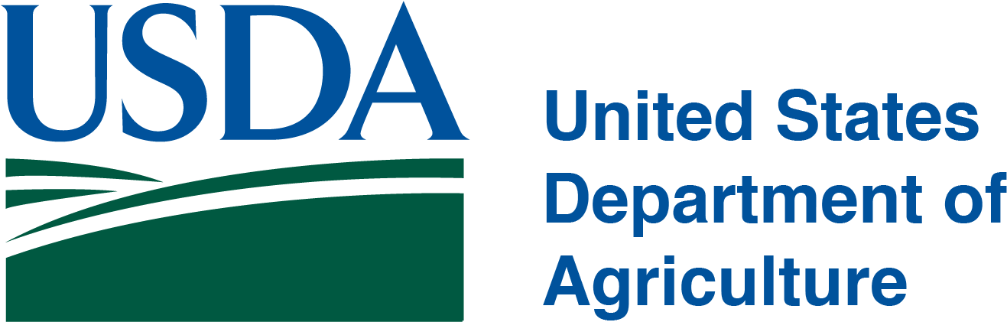

**What’s wrong with modern day agriculture**

Conventional/industrial agriculture is a farming system that utilizes many synthetic chemicals, pesticides, heavy irrigation, and lots of land to produce crops. While farms with this practice produce 80% of the world’s food

(Ritchie 2021), it comes with many environmental losses and poses substantial threats. According to the World Wildlife Fund 2020 Living Planet Report, agriculture covers 37.6% of all land on Earth (about 52% of that will end up degraded) and is responsible for 70% of global freshwater use and 80% of global deforestation.

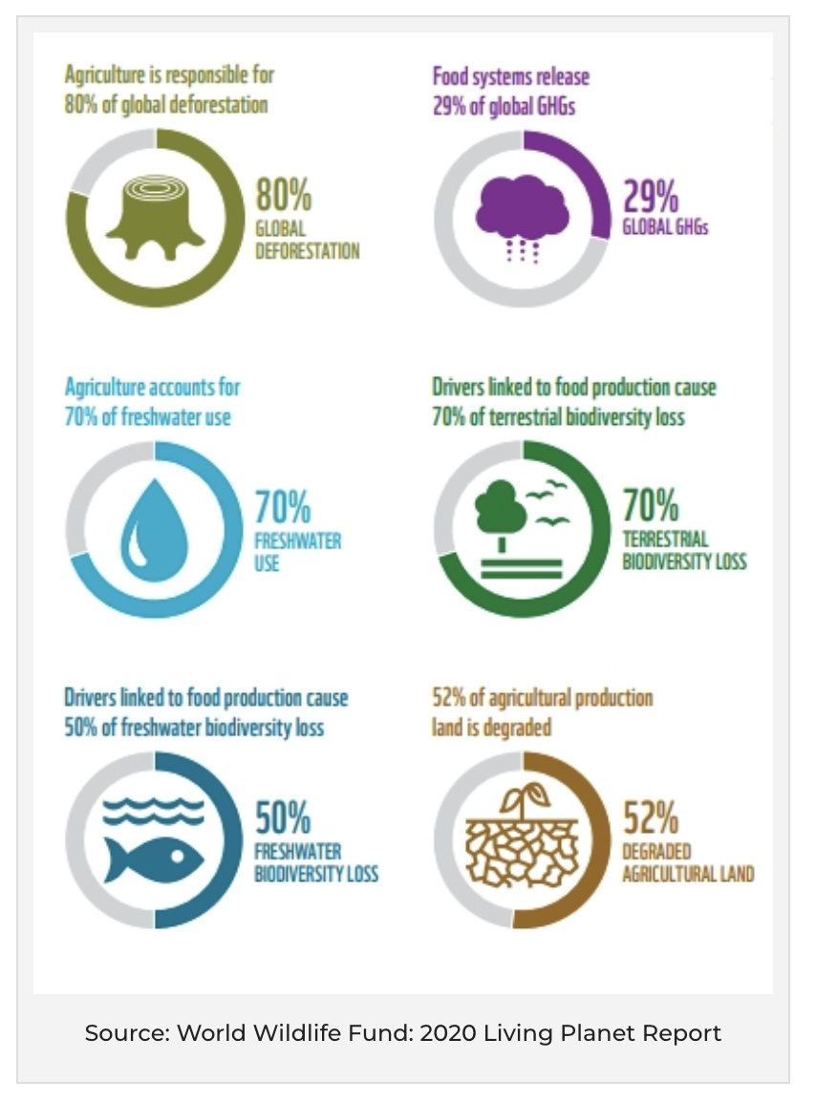

Source: WWF. The environmental impacts of agriculture.

Additionally, drivers associated with food production cause 70% of terrestrial biodiversity loss and 50% of freshwater biodiversity loss (Stevens). Food systems are also responsible for a third of global human-caused greenhouse gas emissions. Modern day agriculture depletes and pollutes natural resources, emits greenhouse gasses, and requires harmful chemicals. In fact, the United Nations reported that conventional agriculture costs the environment the equivalent of about $3 trillion (U.S) every year (UN).

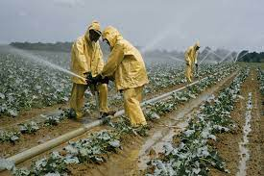

Source: National Geographic. Crops are sprayed with pesticides.

**Importance**

The global population is expected to reach 9 billion by 2050. With a constantly growing domestic and global population, sustainable farming practices must be implemented sooner rather than later to conserve natural resources, reduce emissions, all while meeting food demand. Specifically in the United States, conventional agriculture is responsible for 80-90% of the country’s freshwater and 40% of all land use (*Terrascope*). As the national population, food demand, and food waste increase, these numbers will only go up.

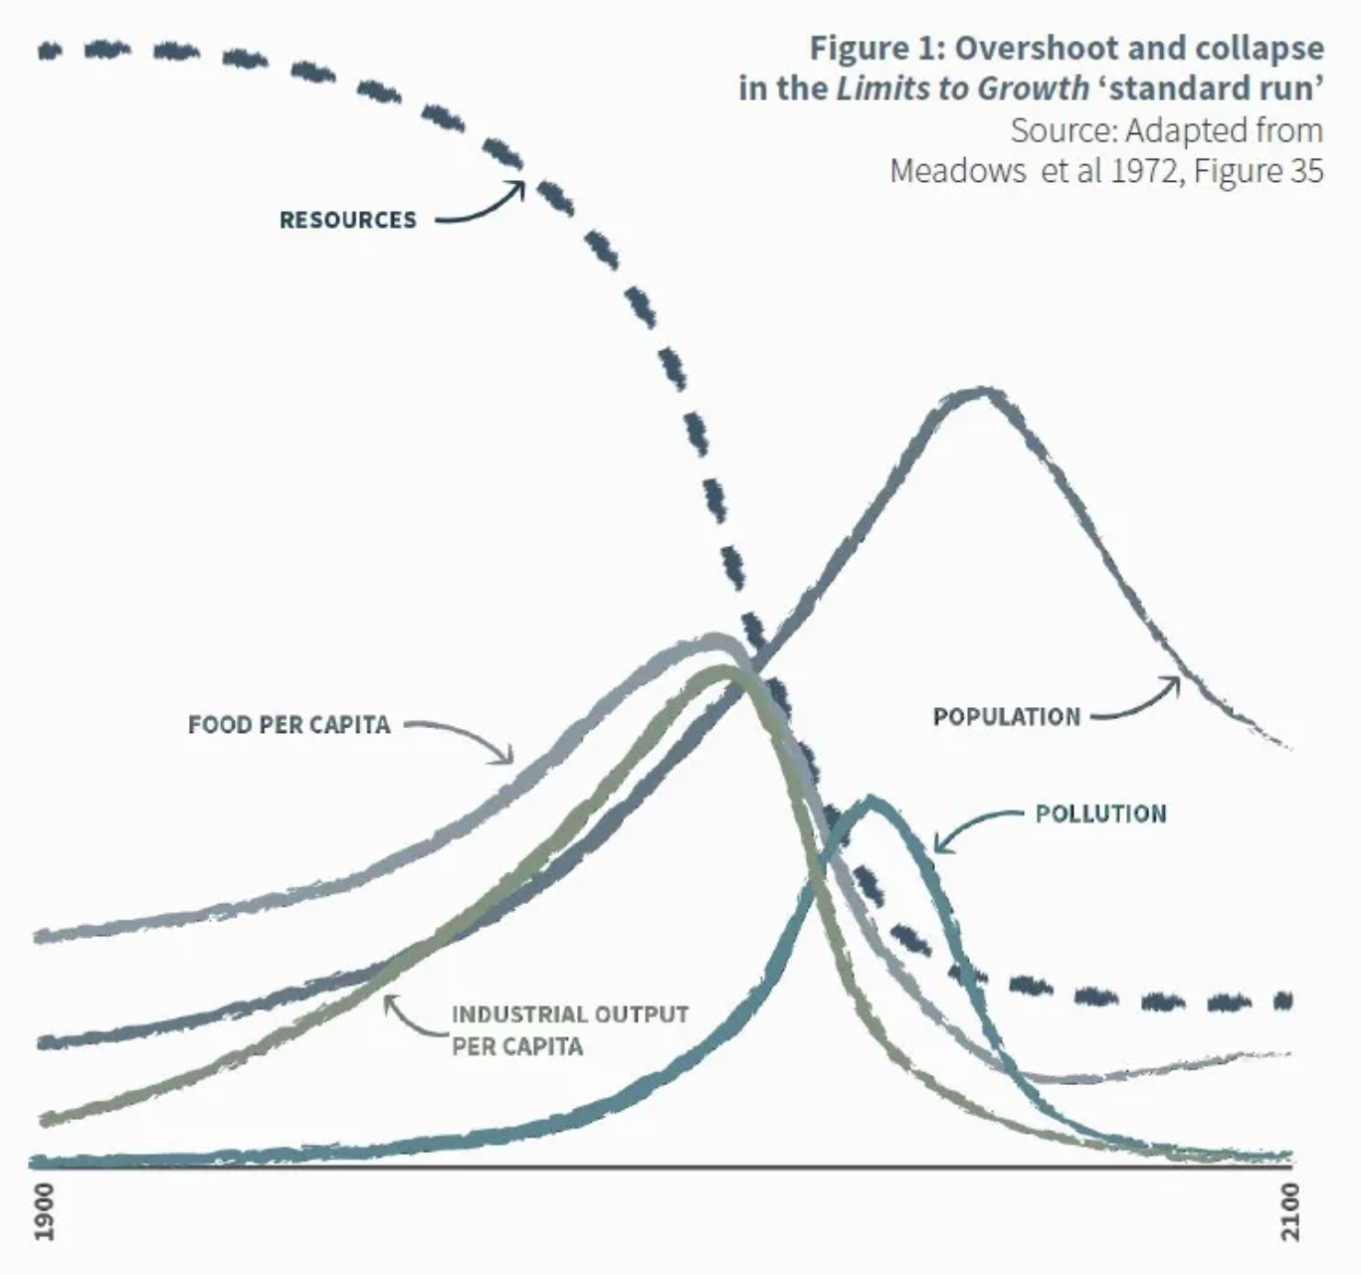

Source: (in photo). 1990 to 2100 predictions of population, resources, pollution, and food per capita.

A study at the University of Wisconsin-Madison found that croplands in the United States are expanding at a rate of more than one million acres per year (*Terrascope*). Increasing agricultural practices as they stand now can pose many threats. Many species’ habitats will be destroyed to make way for more farmland. Increased water use for agriculture can deplete and pollute freshwater sources, negatively impacting the health of surrounding ecosystems/biodiversity, wildlife, and people. As only 3% of the world’s water is fresh (most of that being trapped in glaciers), preserving freshwater now and especially in the future is crucial. Less than four percent of continental United States land and water biodiversity is currently preserved (*Terrascope*). The UN secretary general Antonio Guterres stated that “unless immediate action is taken, it is increasingly clear that an impending global food security emergency could have long-term impacts on hundreds of millions of adults and children” (Robinson). He, alongside many other global leaders and NGOs, urged nations to rethink food systems and encouraged more sustainable farming practices (Robinson) for the health of the environment and its people.

**Current Action**

There are many proposed improvements and replacements to modern day agriculture in the technological realm. One solution is utilizing solar energy. Solar power can cut the use of traditional energy sources like oil and coal. Many farmers are investing in solar greenhouses in place of conventional fields because they can provide controlled temperatures and maintain optimal lighting conditions for the crops to grow and thrive (Stevens). Solar energy is clean and sustainable and can power many things including the production of crops.

Another popular option is vertical farming. Vertical farming is simply the practice of growing crops vertically rather than horizontally. It optimizes plant growth through a controlled environment, where various techniques can be utilized. As of 2020, there are about 74 acres of operational vertical farmland in the world (Terazono). Some advantages of vertical farming technologies include increased crop yield, immunity to weather complications, generation of energy through composting, and less land and water requirement.

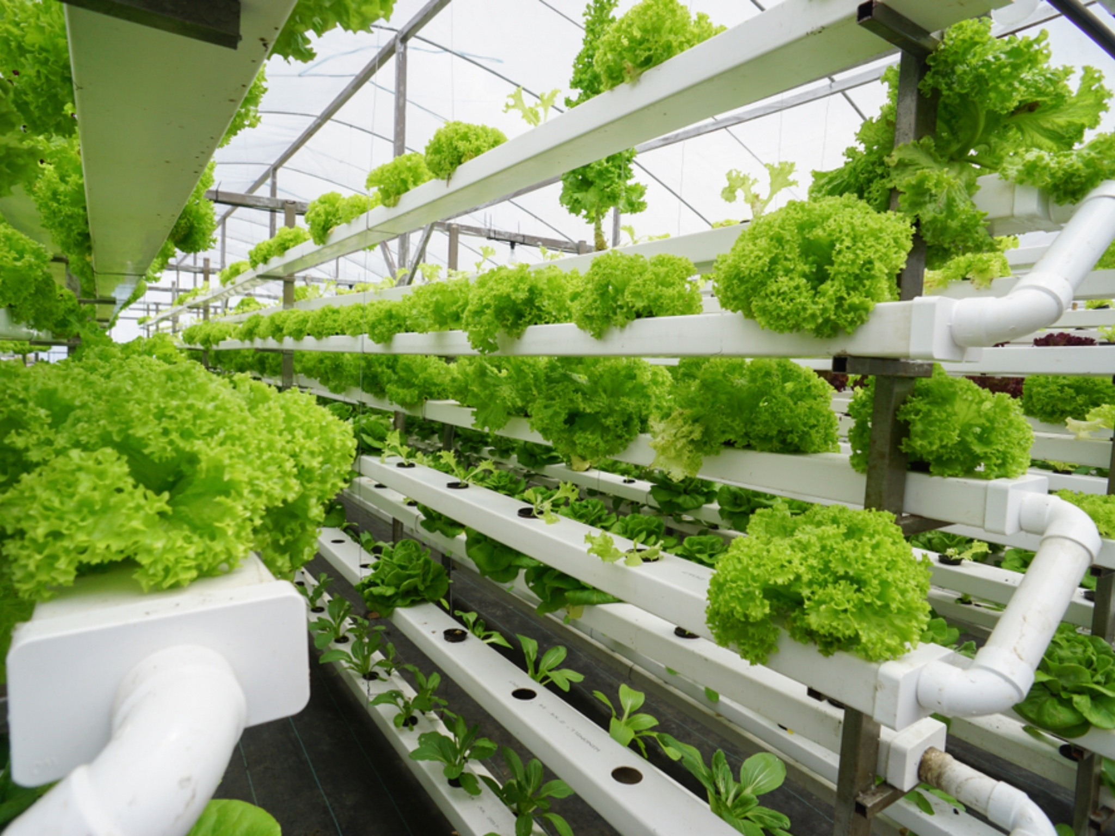

Source: timeout.com, Sophie Dickenson, June 9, 2022

World’s largest vertical farm being built in the UK.

**Recommendations**

We have a few recommendations that center around the idea of slowly introducing hydroponic systems in place of conventional agriculture exclusively in the United States. Hydroponics is a way of growing plants in a controlled environment without using soil and only minimal water, sunlight, and nutrients.

1. For every 750 acres of farmland a person, business, company, etc. uses for agriculture, they are required to have a certain amount of land devoted to hydroponic systems.

This policy does not apply if a farm is smaller than 750 acres.

1. The government will provide tax breaks for every hydroponic system people utilize.

These policies will cut down the amount of farmland used for agriculture. The effects will not be noticeable immediately, but as bigger farms transition to hydroponics, they will reap many benefits and potentially switch over entirely in the future. Also, as people can catch a break from taxes while yielding more crops, they are incentivized to keep using them.

**Why hydroponics?**

Using a catch and reuse system, hydroponics uses ten times less water than traditional agriculture (Jensen). It eliminates the need for fertilizers and pesticides, making the crops healthier for humans, animals, and the environment (Barbosa et al.). Additionally, hydroponics produces a higher yield than conventional agriculture (per GHG unit) (*Terrascope*).

This method can also grow crops in urban and rural areas, thus cutting down on food transportation and waste. From optimal location use, climate control, increased yield, conservation of land and water, and zero need for pesticides, herbicides, and fertilizers, hydroponics are a great, sustainable replacement for wasteful conventional ways of growing crops.

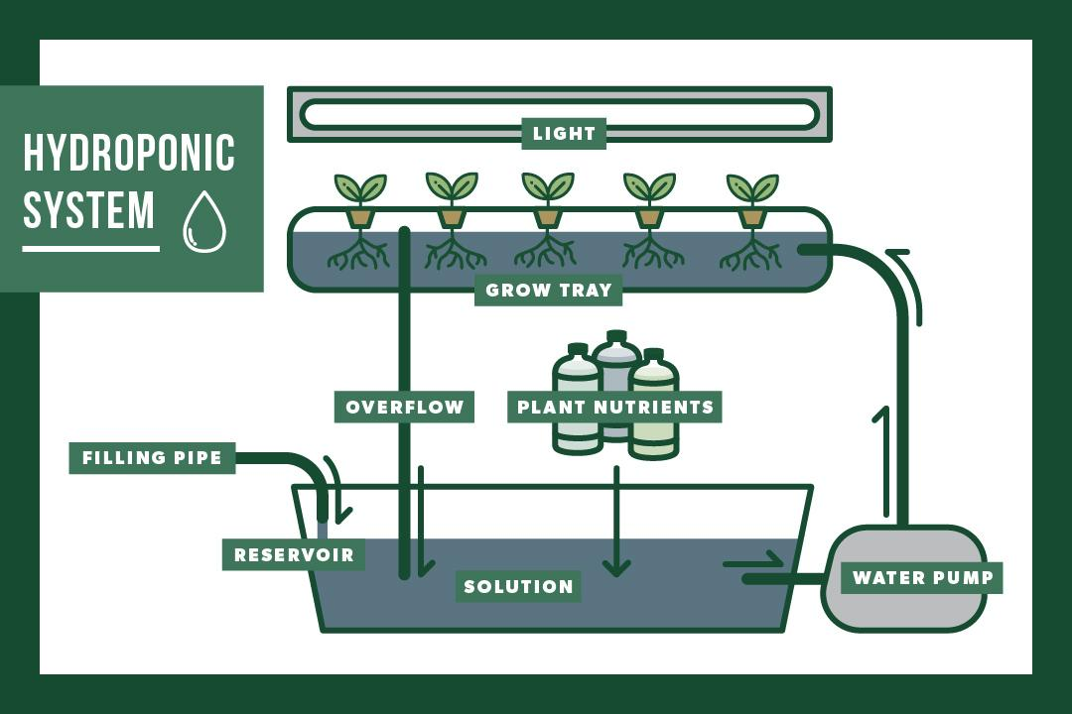

Source: How deep flow technique (DFT) hydroponic systems work. How hydroponics work.

**Why focus on the United States?**

* The U.S spends the third most money on agriculture in the world (using converted currencies to compare easily).
* The U.S produces enough food to feed 10 billion people.
* The U.S emits the third highest amount of greenhouse gasses in the world.
* Regarding resource budget, the United States’ ecological footprint exceeds our biocapacity by 133%, making us the fourth highest country in resource use (TheStreet).

It’s safe to say that compared to many countries, the United States depletes many natural resources, emits tons of greenhouse gasses, and has the funds and population to continue this trend. As leaders in these categories, the U.S should also be a leader in fixing them. Additionally, depending on budget, wealth, population, ecosystems, terrain, and natural resource availability, the solution to creating more stable and sustainable food production will look different for each country.

Keeping policies such as this to a national level will help focus the answer to the specific problem and increase its effectiveness. Similarly, because this green technology can be expensive, it’s best to start in a wealthier country. Holding the exact

expectations for third and second-world countries would not be economically practical everywhere. Finally, many countries have already switched from conventional agriculture to a more sustainable solution, including France, Finland, Japan, and more.

**References**

Adelman, D. E., & Barton, J. H. (2002). Environmental regulation for agriculture: Towards a framework to promote sustainable intensive agriculture. *Stan. Envtl. LJ*, *21*, 3.

Barbosa, Guilherme Lages, et al. “Comparison of Land, Water, and Energy Requirements of Lettuce Grown Using Hydroponic vs. Conventional Agricultural Methods.” *International Journal of Environmental Research and Public Health*, MDPI, 16 June 2015, https://www.ncbi.nlm.nih.gov/pmc/articles/PMC4483736/.

Beaumont, Patricia. “An Overview of Federal Environmental Agencies in America.” *The Green Dandelion*, 11 Jan. 2017, https://blogs.rochester.edu/thegreendandelion/2017/02/an-overview-of-federal-environmental-agencies-in-america/.

Jensen, M. H. (1997). Hydroponics. *HortScience*, *32*(6), 1018-1021.

Robinson, Deena. “The Biggest Environmental Problems of 2021.” *Earth.Org*, 3 Sept. 2022, https://earth.org/the-biggest-environmental-problems-of-our-lifetime/.

Stevens, Mark. “Green Tech: The Innovations Driving Food + Agriculture.” *SIAL America |*, 17 Dec. 2021, https://sialamerica.com/blog/4-types-of-green-technology-in-food-production-and-processing/.

“Environmental Impact.” *Terrascope 2024*, https://terrascope2024.mit.edu/?page_id=315.

Jensen, M. H. (1997). Hydroponics. *HortScience*, *32*(6), 1018-1021.

Staff, TheStreet. “The Countries That Use the Most Resources.” *TheStreet*, TheStreet, 10 Sept. 2018, https://www.thestreet.com/personal-finance/the-countries-that-use-the-most-resources-per-person-14699472.

News. Retrieved December 10, 2021, from

https://news.un.org/en/story/2021 /03/1086822.

Ritchie, Hannah. “Smallholders Produce One-Third of the World's Food, Less than Half of What Many Headlines Claim.” *Our World in Data*, 6 Aug. 2021, https://ourworldindata.org/smallholder-food-production#:~:text=Family%20farms%20do%20produce%20around,not%20be%20confused%20with%20smallholders.

Terazono, Emiko. “Vertical Farming: Hope or Hype?” *Subscribe to Read | Financial Times*, Financial Times, 31 Oct. 2020, https://www.ft.com/content/0e3aafca-2170-4552-9ade-68177784446e.

Dickinson, Sophie. “The World's Largest Vertical Farm Is Being Built in the UK.” *Time Out Worldwide*, Time Out, 9 June 2022, https://www.timeout.com/news/the-worlds-largest-vertical-farm-is-being-built-in-the-uk-060922.

“10 Things You Should Know about Industrial Farming.” *UNEP*, https://www.unep.org/news-and-stories/story/10-things-you-should-know-about-industrial-farming.